Post Exposure Standard Operating Procedures


Date:
PI Name:
Name of Agent:
Mode(s) of Transmission of Parental Agent (e.g. for recombinant lentivirus vectors describe modes of transmission of HIV):
Signs and Symptoms of Exposure/Infection with this Agent (e.g. for recombinant lentivirus vectors describe signs and symptoms of exposure/infection with HIV):

Assessment of Additional Risks
 | Yes | No
Is this agent replication-defective?
Could the agent integrate into the genome?
Does the agent encode a transgene that could lead to an increased risk of oncogenesis?
e.g. Does the transgene encode an oncogene?
Could the transgene inactivate a tumor suppressor?
Does the agent encode a toxin or an immunomodulatory or harmful peptide?
Has the agent been modified to alter drug resistance?
If yes, explain:

Is the agent propagated in cell lines?
- If yes, are the cell lines human or primate?
- If yes, are there any hazards associated with the cells?

Vaccination and Treatment Options
 | Yes | No
Is there a Vaccine available to protect against this agent?
If yes, have personnel been offered vaccination?
Are there Post Exposure Prophylaxis options for this agent?

If yes, describe:

Copy and complete the three tables for each type of agent/viral vector in the laboratory

Actions in the Event of an Exposure

Definition of Exposure
- Direct skin, eye or mucosal membrane exposure to the agent or materials potentially containing the agent, such as tissue culture media or cells, bodily fluids from infected animals.
- Parenteral inoculation by a syringe needle or other contaminated sharp (needlestick),
- Ingestion of liquid suspension of an infected material or by contaminated hand to mouth exposure, or
- Inhalation of infectious aerosols.

Information for Lab Personnel
- Remove exposed PPE taking care to avoid contact of unexposed areas to infectious agents on the PPE.

- Inform others in area about any biohazardous materials out of containment to prevent further exposure. If possible, contain with absorbent pads, decontaminate with bleach, and/or seal off the site. ALL exposed individuals should leave the area.

- Immediately wash affected areas with soap and water, or if exposure to eyes or mucous membranes occurred, immediately flush affected area with water for 10-15 minutes. See exposure procedures for further information.

- After washing, Notify lab supervisor or Principal Investigator of the exposure (PI’s 24-hour Emergency Contact Number: (XXX) XXX-XXXX).

- Go immediately to the RedMed Employee Health Clinic at the University Union Building or the Occupational Medical Clinic at the Redwood Health Center for medical evaluation and follow-up; contact information is below. After 5pm you will be seen by an Urgent Care Physician. After 8pm, or if the injury is serious/life threatening, go to the University of Utah Hospital Emergency Department or call an ambulance (911).

- Ensure that the physician is aware of all materials that were being used at the time of exposure (e.g., virus, bacteria, human tissue, animal tissue, other potentially infected material). Take a completed copy of the risk assessment and treatment options of this SOP with you!

- Follow up with the physician at Occupational Medicine, as requested.

RedMed Employee Health Clinic
200 Central Campus Dr.
Salt Lake City, UT 84112
Phone: (801) 213-3303
Hours: M-TH: 8:00AM – 5:00PM, Friday: 9:00AM – 3:30PM

Redwood Health Center
Occupational Medicine Clinic
1525 West 2100 South
Salt Lake City, UT 84119
Phone: (801) 213-9777
Hours: M-F 8:00AM – 5:00PM
After Hours
Redwood Urgent Care
1525 West 2100 South
Salt Lake City, UT 84119
M-F 5:00PM – 8:00PM
Sat.-Sun.: 9:00AM – 8:00PM
(801) 213-9700

After 8 PM
Emergency Department at University Hospital
(main floor northeast side of the hospital)
50 N. Medical Drive
Salt Lake City, UT 84132
(801) 581-2292

- Post exposure prophylaxis must be initiated as soon as possible after exposure.

- Inform the Healthcare Provider of any medical conditions, such as pregnancy or immunosuppression, or drug treatment that you currently have or take. The Healthcare Provider must have this information to evaluate and develop a proper post treatment evaluation.

- Upon returning to work, fill out the Employers First Report of Injury E1 Form. This form can be downloaded from the human resources website under “Forms” (https://www.hr.utah.edu/forms/index.php).

- After medical care, ensure that the incident is immediately reported to the Biosafety Officer (801-581-6590).

- Have the PI/Supervisor complete a “SPILL OR EXPOSURE EVENT REPORT,” using the template below, and submit to the Biosafety Officer (801-581-6590).

Adapted from the UCLA Post Exposure SOP template (https://ucla.app.box.com/v/ehs-bio-pep-sop-general)

Maps of Occupational Medicine Clinics
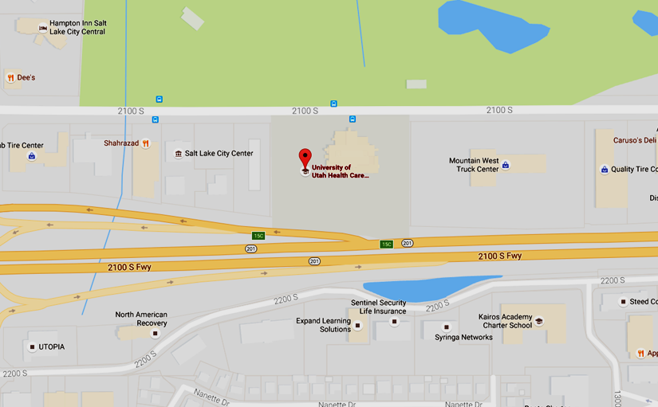
UNIVERSITY OF UTAH REDWOOD HEALTH CENTER OCCUPATIONAL MEDICINE
1525 W. 2100 S. Salt Lake City UT, 84119

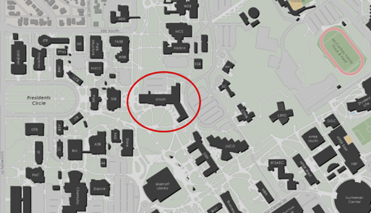

REDMED EMPLOYEE HEALTH CLINIC

200 Central Campus Dr. Salt Lake City, UT 84112
SPILLS OR EXPOSURE EVENT REPORTING PROCEDURE

Any significant problems, violations of the NIH Guidelines, or any significant research-related accidents and illnesses must be reported to the IBC so that a report can be sent to the NIH Office of Science Policy (OSP) within 30 days. Certain types of accidents must be reported on a more expedited basis. Spills or accidents in BL2 laboratories resulting in an overt exposure must be immediately reported to the IBC and PBBP. Spills or accidents occurring in high containment (BL3 or BL4) laboratories resulting in an overt or potential exposure must be immediately reported to OSP.

Any spill or accident involving recombinant or synthetic DNA research of the nature described in the previous paragraph or that otherwise leads to personal injury or illness or to a breach of containment must be reported to the IBC and OSP. These kinds of events might include skin punctures with needles containing recombinant or synthetic DNA, the escape or improper disposition of a transgenic animal, or spills of high-risk recombinant materials occurring outside of a biosafety cabinet. Failure to adhere to the containment and biosafety practices articulated in the NIH Guidelines must also be reported to IBC and OSP.

In addition, exposure to Infectious Agents or Other Potentially Infected Material should be reported to the IBC.

Minor spills of low-risk agents not involving a breach of containment that were properly cleaned and decontaminated generally do not need to be reported. If the investigator, or other institutional staff are uncertain whether the nature or severity of the incident warrants reporting, contact the Biosafety Officer who can assist in making this determination, with guidance from OSP, if necessary.

Please complete the form below and submit to the Biosafety Officer (801-581-6590).

SPILL OR EXPOSURE EVENT REPORT
If a spill or exposure to Recombinant DNA or Synthetic Nucleic Acid Molecules, Infectious Agents or Other Potentially Infected Material occurs in your laboratory, please complete the following information and give to the Biosafety Officer. This will serve as a record of the event and be used for NIH OSP reporting, if necessary.

Date of Event:

Principal Investigator:

IBC Registration #:

Building/Room #:

Location with room (bench, biosafety cabinet, centrifuge, etc.):

Is this work NIH funded?

If yes, please provide the grant number, NIH funding institute or center, NIH program officer contact information (name, email etc):

Type of Event (Spill, puncture wound, etc.):

Names of lab personnel involved/exposed:

Site of exposure (eye, mouth, etc: If applicable):

Agent (Recombinant Lentivirus, recombinant adenovirus, etc);

Gene encoded by vector:

Known Oncogene or predicted to increase risk of oncogenesis (Y or N):

Containment Level (BSL-2-enhanced, BSL-2, etc)

Amount exposed (pfu, µl, etc: if known):

Narrative of post exposure/spill response (please describe disinfectant agents, washing of exposed sites, PPE worn during clean up, etc.)

Did the affected individuals need medical treatment and, if so, where were they treated?

Date submitted to Biosafety Officer:

